Getting Started Guide

ESPLux   
Demonstration Unit

Board Revision: 0.1

2015-07-28

# What’s inside?

In this guide, you can expect step-by-step instructions on how to connect and configure your ESPLux, information on where to go if you have problems and a listing of the default configuration values that come with your ESPLux.

# Overview

Thank you for buying an ESPLux! I hope the setup process is a simple one for you. The general idea is that you need to install your ESPLux in line with whatever light you want to control. There are a few provisos that you will need to keep in mind.

# Specifications

The first revisions of these boards have low ratings. Future revisions will have a new rectification circuit that will allow for higher maximum ratings.

**Maximum Wattage at 12v:** 20W

**Maximum Wattage at 24v:** 40W

What this basically means is you’ll need to use an LED. An incandescent globe is not recommended at this point in time.

# Default wireless details

Each new ESPLux comes set up with a unique SSID. Connect to this Access Point to configure the unit, and join it to your own network.

**SSID:** ESPLux-<unique number>

**Password:** espluxsetup

**IP Address:** 192.168.4.1

# Default settings

When you first turn on your ESPLux, the light will turn on. From here, you can visit the web interface and configure each of the settings listed below.

If you are concerned that any of the default settings will damage your light for any reason, start off with your light disconnected, continue with the setup, and then plug your light in when you are comfortable with your setup. You can see the state of the output on the board itself by checking the status of the small blue LED.

**Light is dimmable:** Yes

**Set light to previous value   
when switch is flipped:** Yes

**Light Name:**  ESPLux

# Status Lights

There are a total of four status lights on your ESPLux. Please see below for a legend.

White: These are the indicator lights you can switch on from the web interface. You can use these to identify which ESPLux you are working with.



Blue: This light will be on when the DC Output is turned on. If the output is dimmed, this light reflects that too.

Green: This light will be on when the unit has power.

# Connecting the wires

There are four wires you need to connect to your ESPLux to get set up. Two are connected to the transformer, two connect to your light. To do this, you will need a 2mm flat blade screwdriver.

Connect the two cables from your transformer into the two screw terminals labelled **AC Input**. The polarity of these does not matter, the circuit will figure it out, even if you give it a DC power supply.

Connect the two cables that go to your light into the two screw terminals labelled **DC Output**. If you are using LED strip, or some other LED that requires a DC input, take note of the polarity here. If you are using a retrofit light, there’s a good chance it doesn’t matter which cable goes where.

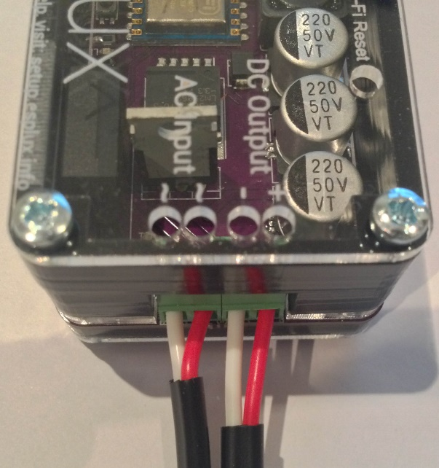

To downlight

To transformer

# Connecting to wireless

Your ESPLux comes pre-configured as an access point. This means you can connect to it with any wireless device, such as a mobile phone, or laptop. To go through setup instructions for each of these devices, it would take a considerable amount of space, so here are the details you’ll need to know to get you by.

**SSID or Network Name:** ESPLux-<random characters>

**Password:** espluxsetup

These should get you connected to your ESPLux. From here, open your favourite web browser, and browse to <http://192.168.4.1>

The following webpage should show up.

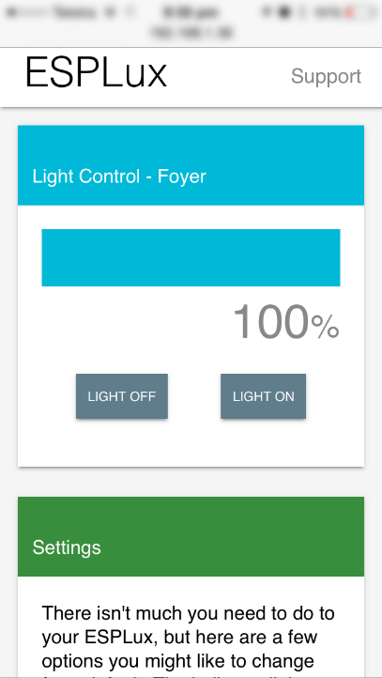

The following sections will step you through each of the options available to you. In reverse order, of course.

# Configuring wireless settings

The first thing you will want to do is configure your wireless settings so that your ESPLux can talk to your computers without having to connect to its own access point.

Scroll down to the bottom of the webpage, to the section called **Wi-Fi**.

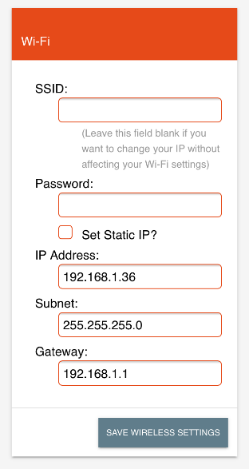

Here you can type in your network details. Your **SSID** and **Password** are for your network. I can’t tell you what they are, they will have been configured when you first set up your network. The setting **Set Static IP** in almost all cases should be set, and an available IP address should be chosen on your network. You can use a piece of software called **Angry IP Scanner** to find free addresses to type in.

When you hit **Save Settings**, ESPLux will do its best to point you to the new address you have set. In the case that this doesn’t work, make sure you are connected to the appropriate network and type the IP address you set above into your web browser. If you have not set a static IP, you will need to go find which address it has been assigned on your router/DHCP server.

# Other ESPLux settings

There are only a few options you need to play with on your ESPLux. Each of them is listed below, with a description of their function;

## Indicator lights

There are two white indicator lights on your ESPLux. This checkbox will turn these lights on until you next flip the light switch, or press the checkbox again. This can be helpful identifying which unit you are controlling, without impacting the external light. It also may provide enough additional light to spot it in a roof cavity if you are lucky!

## Light is dimmable

This will add/remove the dimmer bar from the **Light Control** section of the webpage. This is handy if you have a light that is considered non-dimmable, or you simply do not want this feature turned on.

## Set light to previous value when switch is flipped

When this checkbox is green, the ESPLux remembers the previous state of the light for when you flip the light switch (or lose power). If this is not checked, the light will revert back to full brightness every time. Depending on your setup, you may prefer either option. For example, for a setup without a light switch, you would probably prefer the light to remember its previous setting. When you do have a switch available, having this option disabled might be useful so you can use the light as per normal.

## Light Name

This simply gives you the ability to name your light. If you have two or more units connected to your network, it will take the guesswork out of figuring out which light you are currently using.

# Using your ESPLux

## Web Control

The easiest method of controlling your ESPLux is using the same webpage you’ve been using in the last two sections. The **Light Control** section contains three elements, the dimmer slider and two buttons.

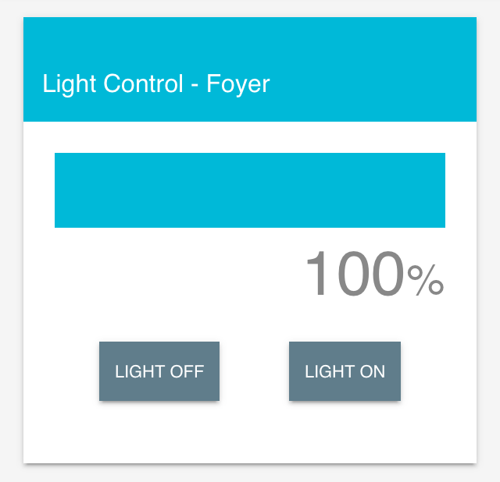

Simply press **Light On** or **Light Off** to switch the light on and off. Alternatively, to dim the light, click anywhere on the blue bar. The further to the left you go, the dimmer your light will be. At this point in time, the bar does not support dragging.

If there is no blue bar in the **Light Control** section, the **Light is dimmable** option may not be checked in the **Settings** section. If your light is capable of dimming, click this button to re-enable it.

## OpenHAB

OpenHAB support will be coming, but is not available at the time this document was written. Please check my project logs at http://esplux.info for more information.

# Troubleshooting and additional information

Having problems? I am sorry about that! Here are hopefully some things that can help you nail down the problem that you are having. If nothing below helps, feel free to visit my website, **esplux.info** and contact me to try get it sorted out. There is a wealth of information about the ESPLux on this page, including the entire log of how the ESPLux came into being.

## Resetting Wireless

If you have changed your wireless settings and need to get your ESPLux reconnected, you will need to reset it back to its factory default option. To do this do the following;

* Turn your ESPLux off
* Put a skewer or some other thin, non-metallic device into the Wi-Fi Reset hole on the top of the unit and press the button on the board
* Hold this down and power the unit back up again.
* The two white indicator LEDs will come on, showing that it has finished resetting the wireless settings.
* You may need to power cycle your ESPLux one more time, depending on timing, but from here you can now follow the **Connecting to wireless** section and reconfigure your wireless settings.

## Simple Checks

There are a few things that you can have a look for to see if everything is working properly.

When the unit has power, a green LED switches on. If you can’t see this light, check that you have the transformer wired into the AC Input terminals as per the **Connecting the wires** section. If the light isn’t on, ensure you are giving it at least 8v, and less than 30v.

If your light isn’t switching on and you believe it should be, check to see if the blue light is lit on the board. It should be a representation of what the light is currently doing. If the blue light is on, and your light isn’t, check the screw terminals are bedded down properly, and that your light is in OK working condition.

If you have changed your ESPLux to use DHCP, and you don’t know what its IP address is, you can use a tool such as Angry IP scanner to try find it on your network, or go through the **Resetting Wireless** guide to reset your unit back to defaults and start again.

Again, if you have any troubles, visit **esplux.info** and ask me any questions you need. I hope your experience with ESPLux has been a pleasant one.